Problem1:Input & output
#include <iostream>
using namespace std;
int main() {
int size;
cout << "Enter the array size : ";
cin >> size;
int arr[size];
for (int i = 0; i < size; i++) {
cout << "Enter element " << ": ";
cin >> arr[i];
}
cout << "Array element: ";
for (int i = 0; i < size; i++) {
cout << arr[i] << " ";
}
cout << endl;
return 0;
}
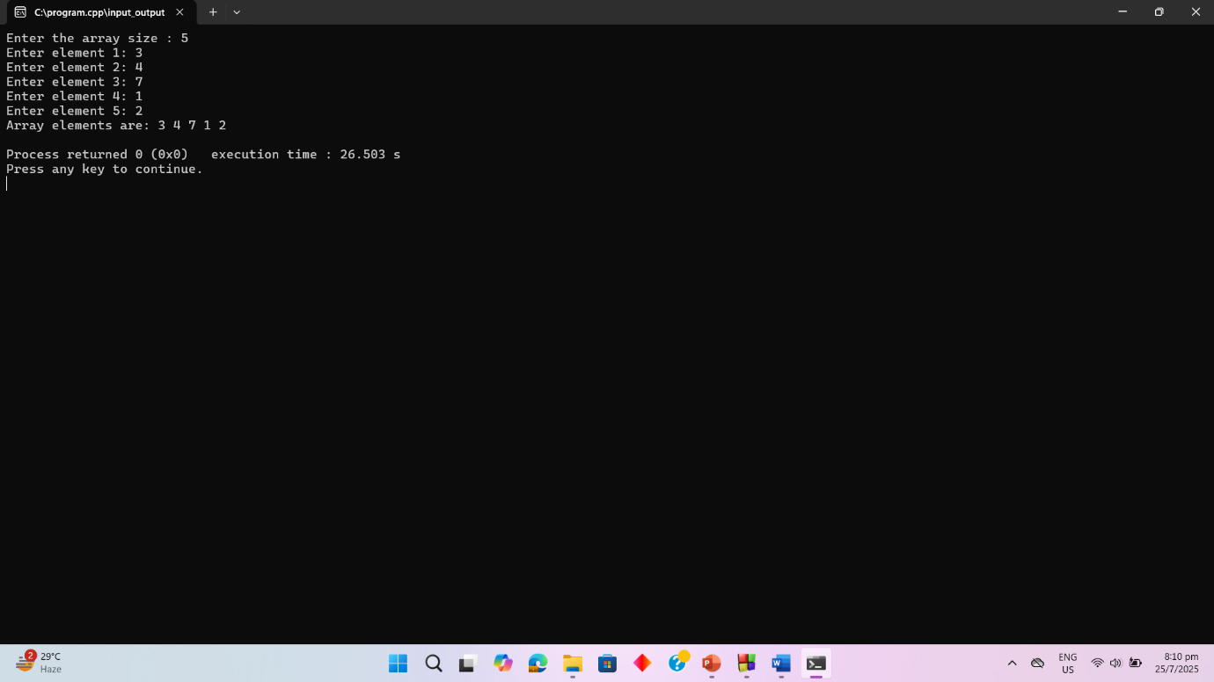

Problem2:Highest & lowest value
#include <iostream>
using namespace std;

int main() {
int size;
cout << "Enter the array size : "<<endl;
cin >> size;
int arr[size];
for (int i = 0; i < size; i++) {
cout << "Enter element " << ": ";
cin >> arr[i];
}
cout << "Array elements: "<<endl;
for (int i = 0; i < size; i++) {
cout << arr[i] << " ";
}
cout << endl;

int highest = arr[0];
int lowest = arr[0];
for (int i = 1; i < size; i++) {
if (arr[i] > highest) {
highest = arr[i];
}
if (arr[i] < lowest) {
lowest = arr[i];
}
}

cout << "Highest number: " << highest << endl;
cout << "Lowest number: " << lowest << endl;

return 0;
}
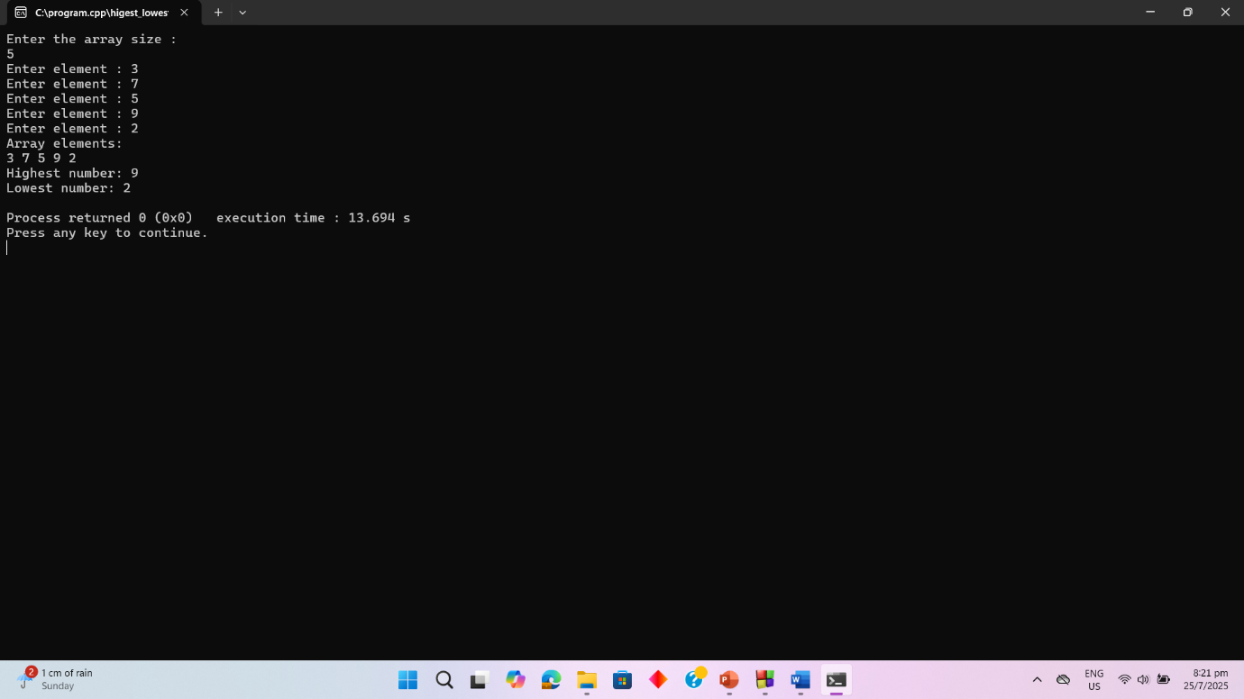

Problem3: Merge two arrays and print in reverse
#include<iostream>
using namespace std;
int main(){

int arr1[]={10, 20, 30, 40,50};
int arr2[]={1,2,3,4,5,6,7,8};
int size1=5;
int size2=8;
int merge[30];

for(int i=0;i<size1;i++){

merge[i]=arr1[i];
}
for(int i=0;i<size2;i++){
merge[size1+i]=arr2[i];
}
for(int i = size1 + size2 -1; i>=0;i--){
cout<<merge[i]<<" ";
}

}
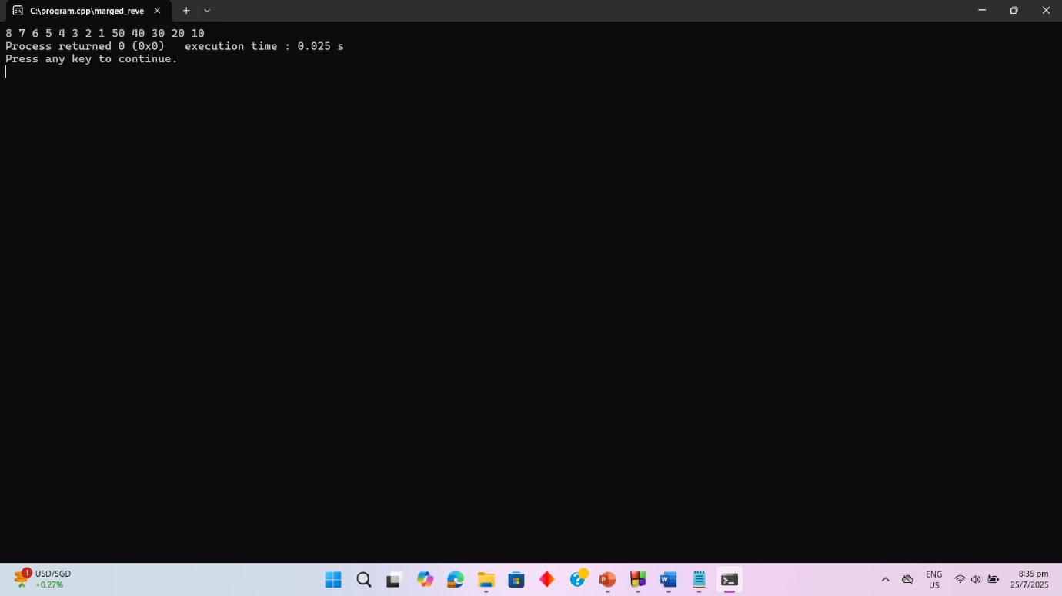

Problem4: Create new array from common elements of A and B

#include <iostream>
using namespace std;
int main() {
int arr1[] = {1,4,6,3,6,9};
int arr2[] = {5,3,7,1,2,6};
int size1= 6, size2 = 6;
int count1 = 0;
cout << "Scenario 1 : ";
for (int i = 0; i < size1; i++) {
for (int j = 0; j < size2; j++) {
if (arr1[i] == arr2[j]) {
cout << arr1[i] << " ";
count1++;
break;
}
}
}
if (count1 == 0) {
cout << "No common element!";
}
cout << endl;
int arr3[] = {1,4,6,3,6,9};
int arr4[] = {5,8,7,12,21,63};
int size3 = 6, size4 = 6;
int count2 = 0;
cout << "Scenario 2 : ";
for (int i = 0; i < size3; i++) {
for (int j = 0; j < size4; j++) {
if (arr3[i] == arr4[j]) {
cout << arr3[i] << " ";
count2++;
break;
}
}
}
if (count2 == 0) {
cout << "No common element!";
}
cout << endl;
return 0;
}
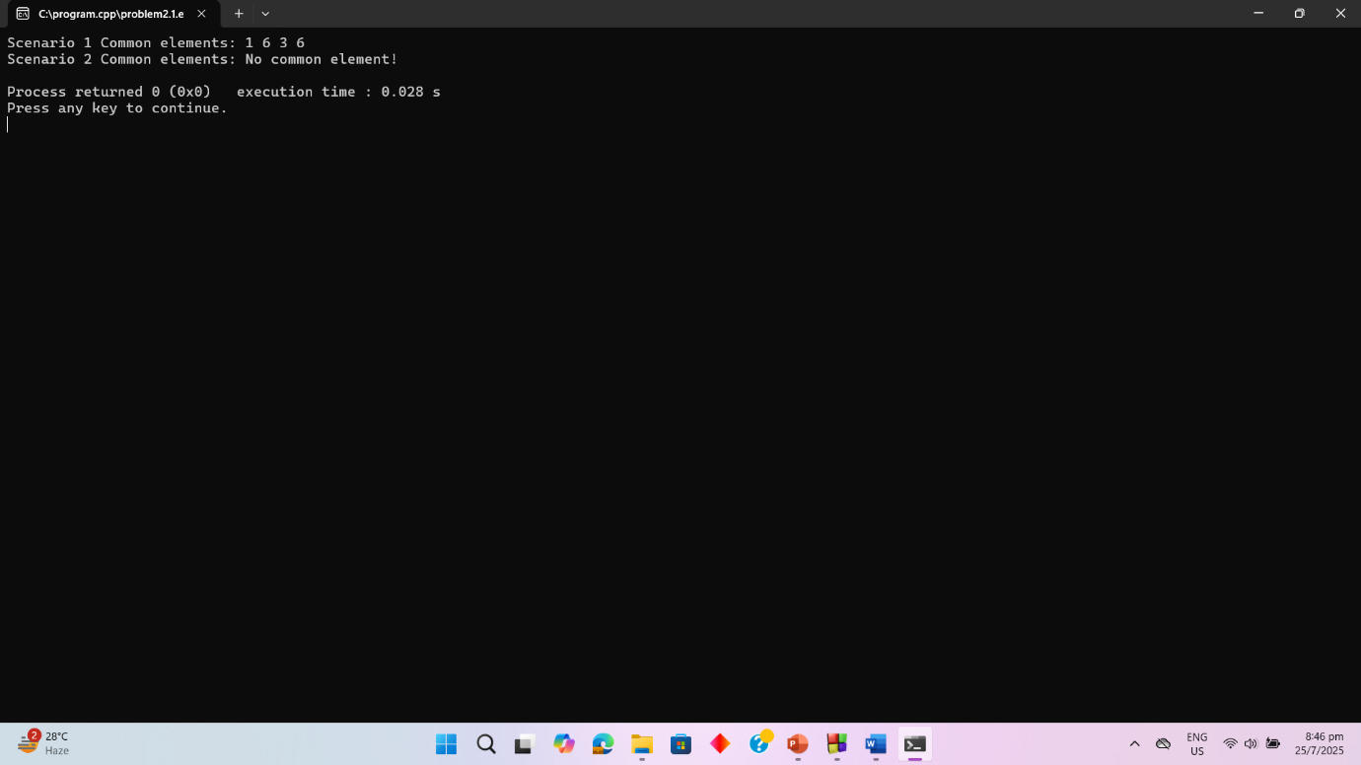

Problem5: Remove duplicates element from an array

#include <iostream>
using namespace std;
int main() {
int arr1[50] = {1, 4, 6, 3, 6, 9, 1};
int size1 = 7;
int arr2[50] = {1, 4, 5, 3, 6, 9};
int size2 = 6;

int newArr1[50];
int newSize1 = 0;

for (int i = 0; i < size1; i++) {
int found = 0;
for (int j = 0; j < newSize1; j++) {
if (arr1[i] == newArr1[j]) {
found = 1;
break;
}
}
if (found == 0) {
newArr1[newSize1] = arr1[i];
newSize1++;
}
}

cout << "Scenario 1 : ";
if (newSize1 < size1) {
for (int i = 0; i < newSize1; i++) {
cout << newArr1[i] << " ";
}
cout << endl;
} else {
cout << "Array already unique!" << endl;
}

int newArr2[50];
int newSize2 = 0;

for (int i = 0; i < size2; i++) {
int found = 0;
for (int j = 0; j < newSize2; j++) {
if (arr2[i] == newArr2[j]) {
found = 1;
break;
}
}
if (found == 0) {
newArr2[newSize2] = arr2[i];
newSize2++;
}
}

cout << "Scenario 2 : ";
if (newSize2 < size2) {
for (int i = 0; i < newSize2; i++) {
cout << newArr2[i] << " ";
}
cout << endl;
} else {
cout << "Array already unique!" << endl;
}
return 0;
}

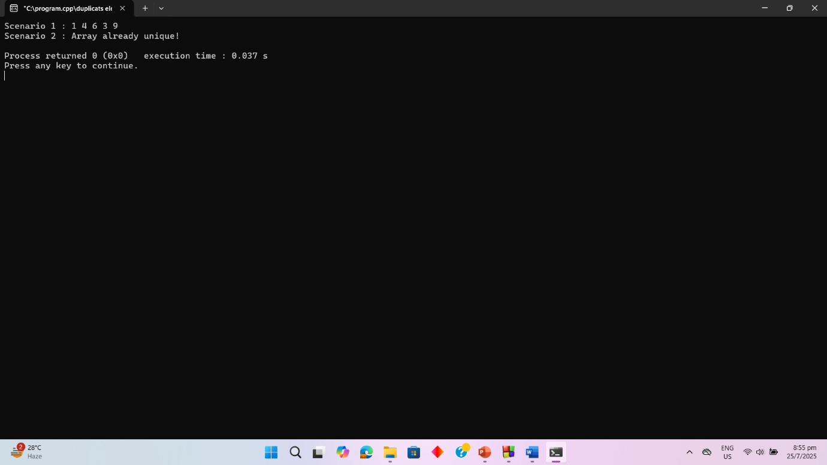

Problem6: Count occurs number in array
#include <iostream>
using namespace std;
int main() {
int A[10] = {8, 4, 6, 1, 6, 9, 6, 1, 9, 8};
int num, count = 0;
cout << "Input a number to search: ";
cin >> num;
for (int i = 0; i < 10; i++) {
if (A[i] == num) {
count++;
}
}
cout << "The number occurs " << count << " times in the array" << endl;
return 0;
}
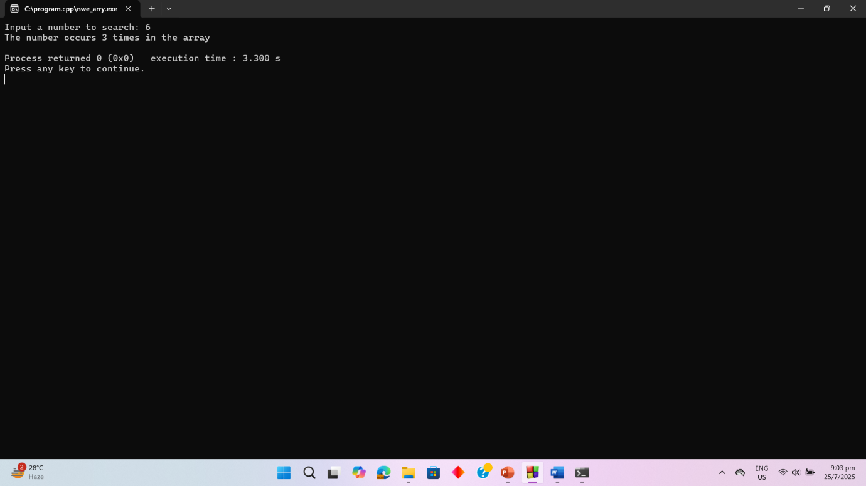

Problem7: Count how many times each element occurs in the array
#include <iostream>
using namespace std;
int main() {
int arr[10] = {8, 4, 6, 1, 6, 9, 6, 1, 9, 8};
int count;
int alreadyCounted;

for (int i = 0; i < 10; i++) {
alreadyCounted = 0;
for (int j = 0; j < i; j++) {
if (arr[i] == arr[j]) {
alreadyCounted = 1;
break;
}
}

if (alreadyCounted == 0) {
count = 1;
for (int k = i + 1; k < 10; k++) {
if (arr[i] == arr[k]) {
count++;
}
}

cout << arr[i] << " occurs = " << count << " time";
if (count > 1) {
cout << "s";
}
cout << endl;
}
}
return 0;
}
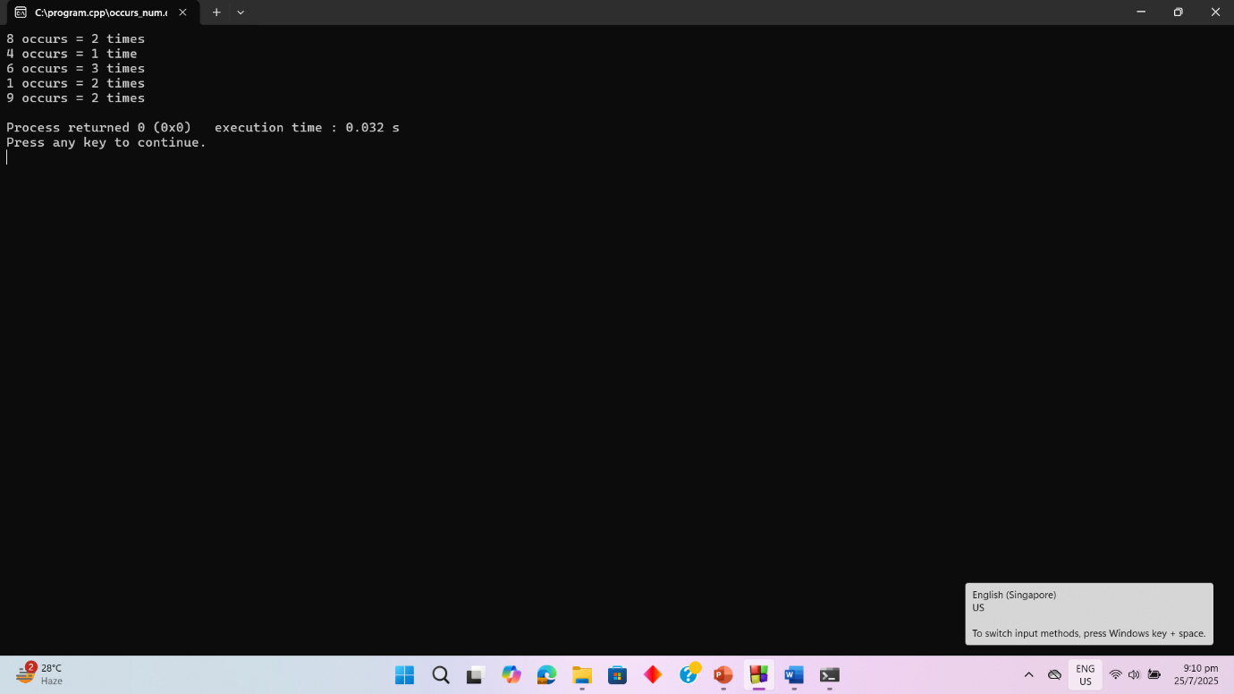

Problem8: Initialize a matrix & Output of transpose matrix
#include <iostream>
using namespace std;
int main() {
int m1[3][4] = {
{1, 6, 7, 9},
{2, 4, 8, 5},
{3, 1, 9, 4}
};
cout << " Matrix 1:" << endl;
for (int i = 0; i < 3; i++) {
for (int j = 0; j < 4; j++) {
cout << m1[i][j] << " ";
}
cout << endl;
}
cout << "output:" << endl;
for (int j = 0; j < 4; j++) {
for (int i = 0; i < 3; i++) {
cout << m1[i][j] << " ";
}
cout << endl;
}
return 0;
}
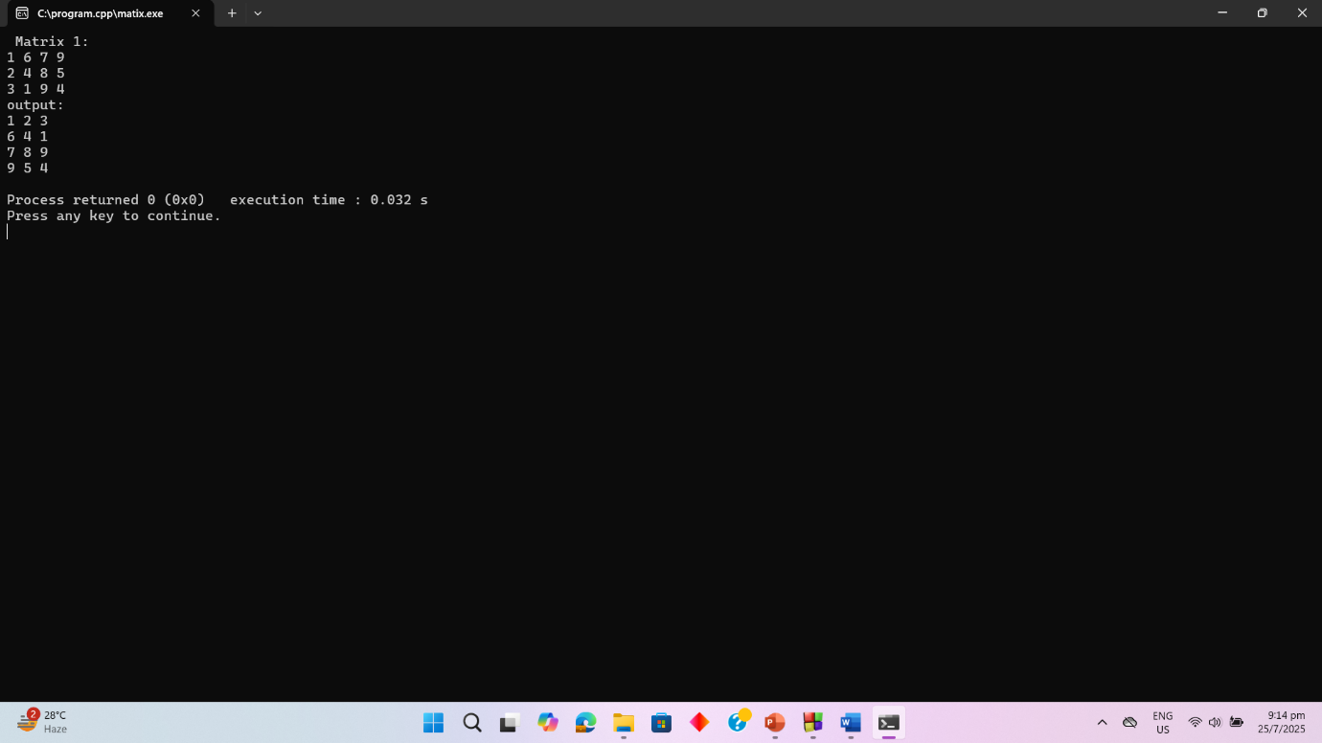
Problem9: Encode a string by skipping letters and increasing ASCII
#include <iostream>
#include <string>
using namespace std;
string encode(string s, int j) {
for (int i = j; i < s.length(); i += (j + 1)) {
s[i] = s[i] + 2;
}
return s;
}
int main() {
string s = "I am a student";
int j = 2;
string result = encode(s, j);
cout << "Converted String: " << result << endl;
return 0;
}
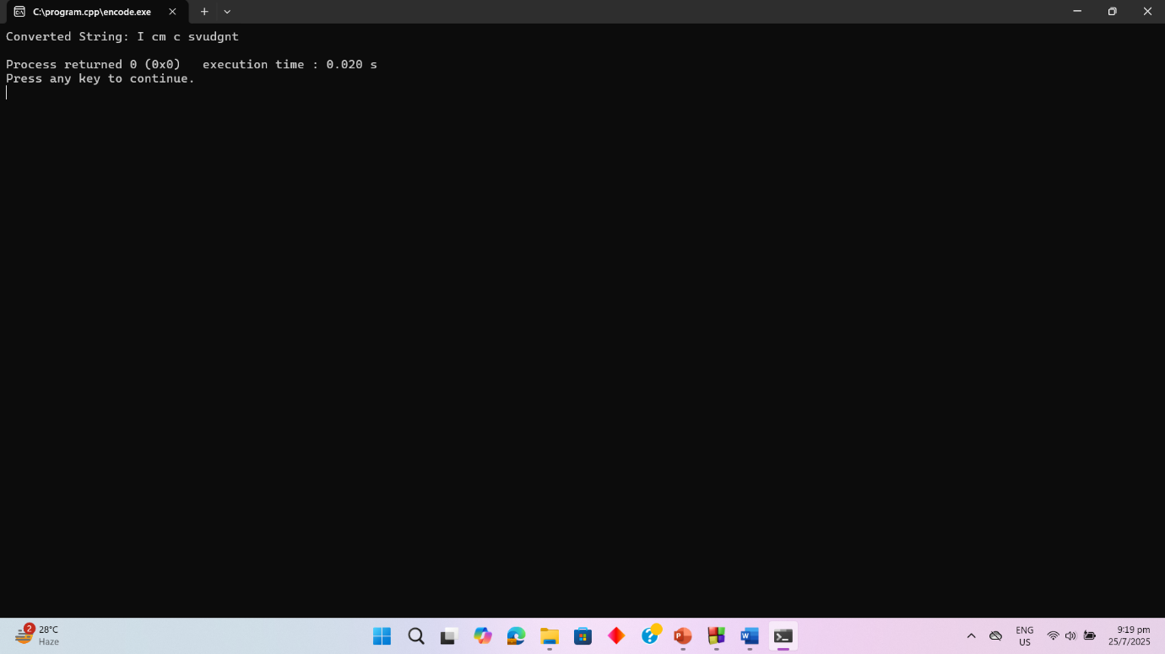

Problem10: Student Records Using Structure and Condition

#include <iostream>
using namespace std;

struct Student {
int Id;
int credit;
float cgpa;
};

int main() {
Student students[10];

for (int i = 0; i < 10; i++) {
cout << "Enter ID, Credits, CGPA for student : " << i + 1 << endl;
cin >> students[i].Id >> students[i].credit >> students[i].cgpa;
}

cout << "Students with CGPA > 3.75"<<endl;
for (int i = 0; i < 10; i++) {
if (students[i].cgpa > 3.75) {
cout << "ID: " << students[i].Id << endl;
}
}

cout << "Students with Credits > 50"<<endl;
for (int i = 0; i < 10; i++) {
if (students[i].credit > 50) {
cout << "ID: " << students[i].Id << endl;
}
}

return 0;
}

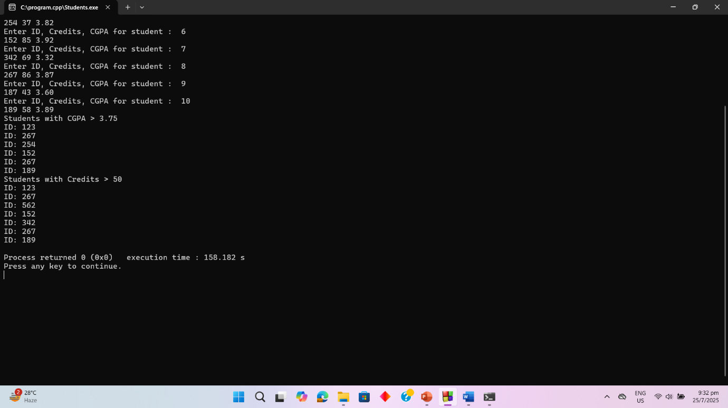

Problem11:Bubble Sort
#include<iostream>
using namespace std;
int main(){
int arr[]={92, 82,21,16,18,95};
int n=6;
int tem;
int com=0, swaps=0;
for(int i=0; i<n-1;i++){
for(int j=0; j<n-i-1; j++){

com++;

if(arr[j]>arr[j+1]){
tem=arr[j];
arr[j]=arr[j+1];
arr[j+1]=tem;

swaps++;
}
}
}

cout<<"shorted array"<<endl;
for(int i=0; i<n; i++){
cout<<arr[i]<<" ";
}
cout<<endl;
cout<<" comparisons number : "<<com<<endl;
cout<<" number or swaps : "<<swaps<<endl;

return 0;
}

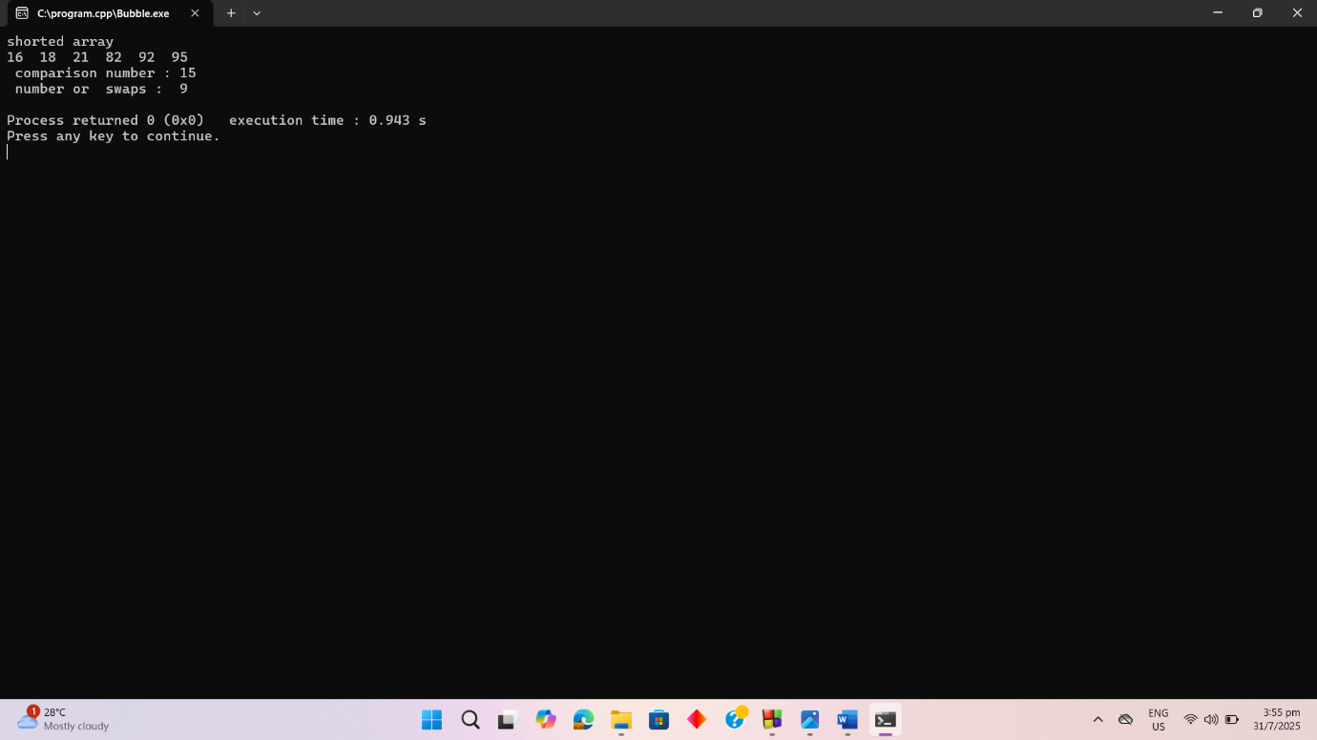

Problem12:Binary Search
#include <iostream>
using namespace std;
int binarySearch(int arr[], int target) {
int st = 0;
int end = 5;
while (st <= end) {
int mid = (st + end) / 2;

if (arr[mid] == target)
{
return mid;
}
else if (arr[mid] > target) {
end = mid - 1;}
else {
st = mid + 1;}
}

return -1;
}

int main() {
int arr[] = {16,18,21,82,92,95};
int target = 82;
int index = binarySearch(arr, target);
if (index != -1)
cout << "Found at index: " << index << endl;
else
cout << "Not found" << endl;
return 0;
}

